Lab sheet 7

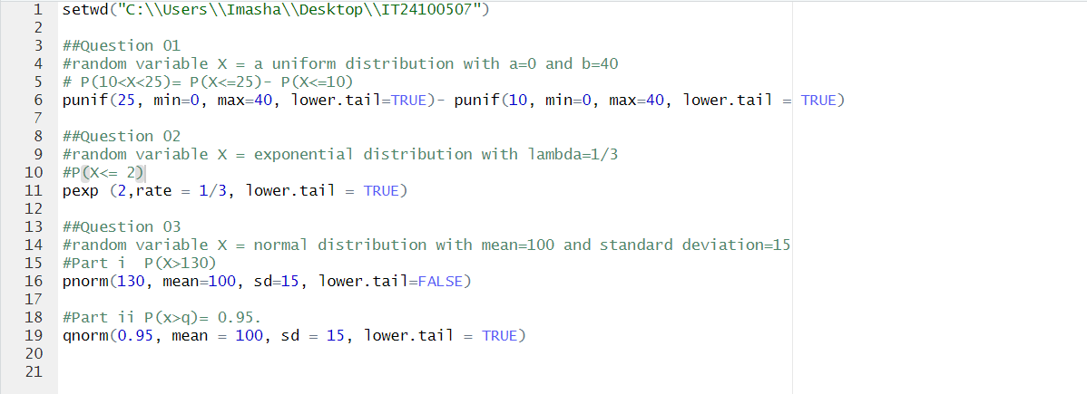

Out put

